IBM – NALAIYA THIRAN PROJECT

# NUTRITION ASSISTANT APPLICATION

**INDUSTRY MENTOR : SAI PRIYA FACULTY MENTOR : ASHOK**

**TEAM ID :** PNT2022TMID07854

**TEAM LEAD :** USHABALA R

**TEAM MEMBER :** RACHEL FABIANA A

**TEAM MEMBER :** KARTHIKEYAN K

**TEAM MEMBER :** CHANDRA HARI S

**TABLE OF CONTENT**

|  |  |  |
| --- | --- | --- |
| **CHAPTER** | **CONTENTS** | **PAGE NO** |
| **1** | **INTRODUCTION**   * 1. PROJECT OVERVIEW   2. PURPOSE | **04** |
| **2** | **LITERATURE SURVEY**   * 1. EXISTING PROBLEM   2. REFERENCES   3. PROBLEM STATEMENT DEFINITION | **05** |
| **3** | **IDEATION & PROPOSED SOLUTION**   * 1. EMPATHY MAP CANVAS   2. IDEATION & BRAINSTROMING   3. PROPOSED SOLUTION   4. PROBLEM SOLUTION FIT | **08** |
| **4** | **REQUIREMENT ANALYSIS**   * 1. FUNCTIONAL REQUIREMENT   2. NON-FUNCTIONAL REQUIREMENTS | **12** |
| **5** | **PROJECT DESIGN**   * 1. DATA FLOW DIAGRAMS   2. SOLUTION & TECHNICAL ARCHITECTURE   3. USER STORIES | **13** |
| **6** | **PROJECT PLANNING & SCHEDULING**   * 1. SPRINT PLANNING & ESTIMATION   2. SPRINT DELIVERY SCHEDULE   3. REPORTS FROM JIRA | **18** |

|  |  |  |
| --- | --- | --- |
| **7** | **CODING & SOLUTIONING**   * 1. FEATURE 1   2. FEATURE 2   3. DATABASE SCHEMA | **20** |
| **8** | **TESTING**   * 1. TEST CASES   2. USER ACCEPTANCE TESTING | **23** |
| **9** | **RESULTS**  9.1 PERFORMANCE METRICS | **24** |
| **10** | **ADVANTAGES & DISADVANTAGES** | **25** |
| **11** | **CONCLUSION AND FUTURE SCOPE** | **25** |
|  | **APPENDIX**  SOURCE CODE PROJECT DEMO LINK | **26** |

## INTRODUCTION

Chronic diseases such as diabetes, obesity, and cardiovascular diseases are becoming the dominant sources of mortality and morbidity worldwide and recently an epidemic in many Asia Pacific countries. Unhealthy diet is one of the key common modifiable risk factors in preventing and managing chronic diseases. Personalized dietary intake intervention showed significant impact on influencing people’s choice and promoting their health. The feedback on nutrition intake is substantial and behavioural changing when patients track their dietary intake for a considerable length of time. However, the burden of logging food makes compliance a challenge. Clinical studies rely on patients to recall dietary intake, which is time-consuming and prone to underestimation

## PROJECT OVERVIEW

Tracking dietary intake is an important task for health management especially for chronic diseases such as obesity, diabetes, and cardiovascular diseases. Given the popularity of personal handheld devices, mobile applications provide a promising low-cost solution to tackle the key risk factor by diet monitoring. In this work, we propose a photo based dietary tracking system that employs deep-based image recognition algorithms to recognize food and analyze nutrition. The system is beneficial for patients to manage their dietary and nutrition intake, and for the medical institutions to intervene and treat the chronic diseases. To the best of our knowledge, there are no popular applications in the market that provide a high-performance food photo recognition like ours, which is more convenient and intuitive to enter food than textual typing.

## PURPOSE

Experiments on evaluating the recognition accuracy on laboratory data and real user data on food, which shed light on uplifting lab trained image recognition models in real applications. We have also conducted user study to verify that our proposed method has the potential to foster higher user engagement rate as compared to existing apps based dietary tracking approaches.

4

## LITERATURE SURVEY

**EXISTING PROBLEM**

With the rapid development of smart computing and Internet of Things (IoT), now we have a huge amount of data from social networks and mobile networks everyday. People keep uploading, sharing and recording what they do everyday in case of missing the chance of using them to improve our daily life. Food images, recipes and food diaries become the most popular information to be shared, we can learn the implication to build an automatic nutrition analysi system by taking the advantage of such large-scale datasets. With the help of food recognition and analysis systems, users are able to record their daily meals and assess dietary habits, as well as promote their health.

## REFERENCES

1. P. Dollar and C. L. Zitnick, ‘‘Fast edge detection using structured forests,’’ IEEE Trans. Pattern Anal. Mach. Intell., vol. 37, no. 8, pp. 1558–1570, Aug. 2014.
2. T. Ege and K. Yanai, ‘‘Image-based food calorie estimation using knowledge on food categories, ingredients and cooking directions,’’ in Proc. Thematic Workshops ACM Multimedia-Thematic Workshops, 2017, pp. 367–375.
3. Eldridge, C. Piernas, A.-K. Illner, M. Gibney, M. Gurinović, J. D. Vries, and

J. Cade, ‘‘Evaluation of new technology-based tools for dietary intake assessment—An ilsi europe dietary intake and exposure task force evaluation,’’ Nutrients, vol. 11, no. 1, p. 55, 2019.

1. S. Fang, Z. Shao, R. Mao, C. Fu, E. J. Delp, F. Zhu, D. A. Kerr, and C. J. Boushey, ‘‘Single-view food portion estimation: Learning Image-to-Energy mappings using generative adversarial networks,’’ in Proc. 25th IEEE Int. Conf. Image Process. (ICIP), Oct. 2018, pp. 251–255.
2. P. F. Felzenszwalb, ‘‘Representation and detection of deformable shapes,’’ IEEE Trans. Pattern Anal. Mach. Intell., vol. 27, no. 2, pp. 208–220, Feb. 2005.
3. E. A. Finkelstein, J. G. Trogdon, J. W. Cohen, and W. Dietz, ‘‘Annual medical spending attributable to obesity: Payer-and service-specific 5 estimates,’’ Health Affairs, vol. 28, no. 5, pp. w822–w831, Jan. 2009.
4. Z. Ge, C. McCool, C. Sanderson, and P. Corke, ‘‘Modelling local deep convolutional neural network features to improve fine-grained image classification,’’ in Proc. IEEE Int. Conf. Image Process. (ICIP), Sep. 2015, pp. 4112–4116.
5. R. Girshick, ‘‘Fast R-CNN,’’ in Proc. IEEE Int. Conf. Comput. Vis. (ICCV), Dec. 2015, pp. 1440–1448.
6. R. Girshick, J. Donahue, T. Darrell, and J. Malik, ‘‘Rich feature hierarchies for accurate object detection and semantic segmentation,’’ in Proc. IEEE Conf. Comput. Vis. Pattern Recognit., Jun. 2014, pp. 580–587.
7. H. Hassannejad, G. Matrella, P. Ciampolini, I. De Munari, M. Mordonini, and S. Cagnoni, ‘‘Food image recognition using very deep convolutional networks,’’ in Proc. 2nd Int. Workshop Multimedia Assist. Dietary Manage. (MADiMa), 2016, pp. 41–49

## PROBLEM STATEMENT DEFINITION

Due to the ignorance of healthy food habits, obesity rates are increasing at an alarming speed, and this is reflective of the risks to people’s health. People need to control their daily calorie intake by eating healthier foods, which is the most basic method to avoid obesity.

However, although food packaging comes with nutrition (and calorie) labels, it’s still not very convenient for people to refer to App-based nutrient dashboard systems which can analyse real-time images of a meal and analyse it for nutritional content which can be very handy and improves the dietary habits, and therefore, helps in maintaining a healthy lifestyle.

The main objective of this project is to building a web App that automatically estimates food attributes such as ingredients and nutritional value by classifying the input image of food.

**Customer Problem Statement Template:**

Create a problem statement to understand your customer's point of view.

The Customer Problem Statement template helps you focus on what matters to

create experiences people will love.

A well-articulated customer problem statement allows you and your team

to find the ideal solution for the challenges your customers face. Throughout the

process, you’ll also be able to empathize with your customers, which helps

you better understand how they perceive your product or service

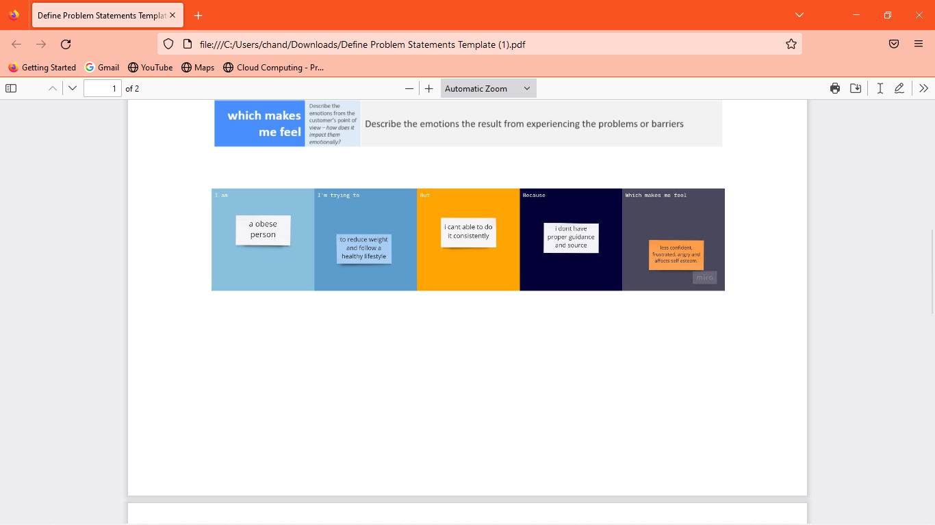

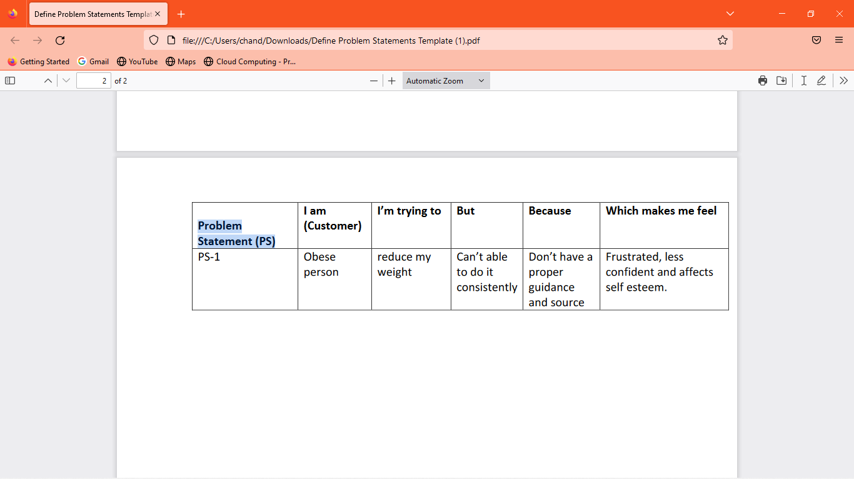

## IDEATION AND PROPOSED SYSTEM EMPATHY MAP CANVAS

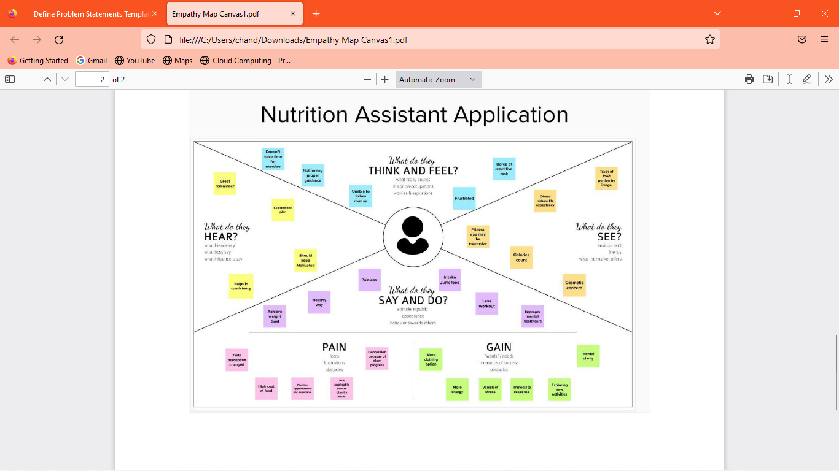

**IDEATION AND BRAINSTORMING**

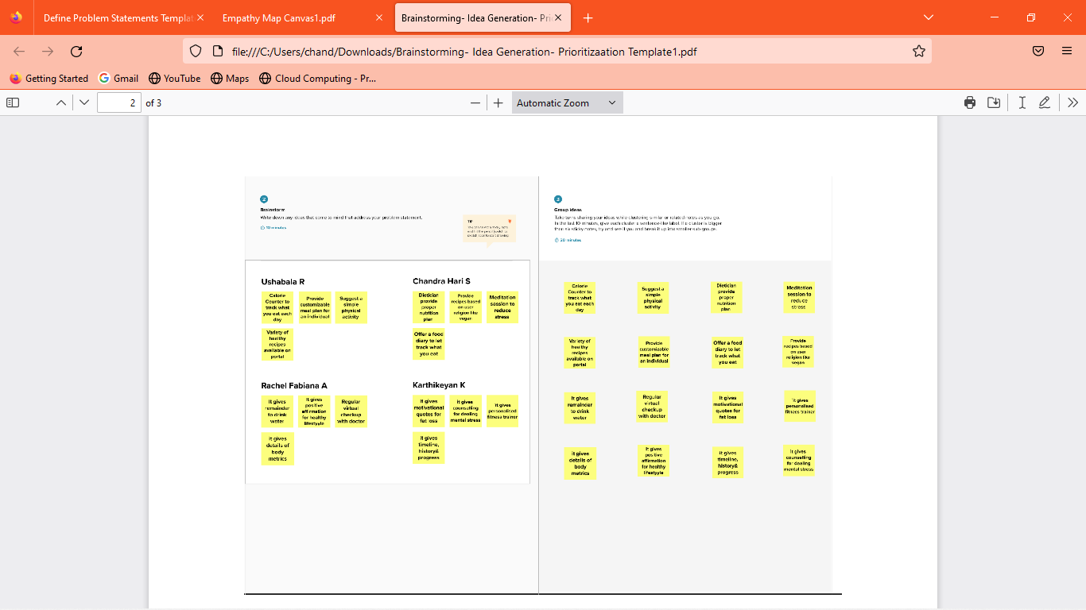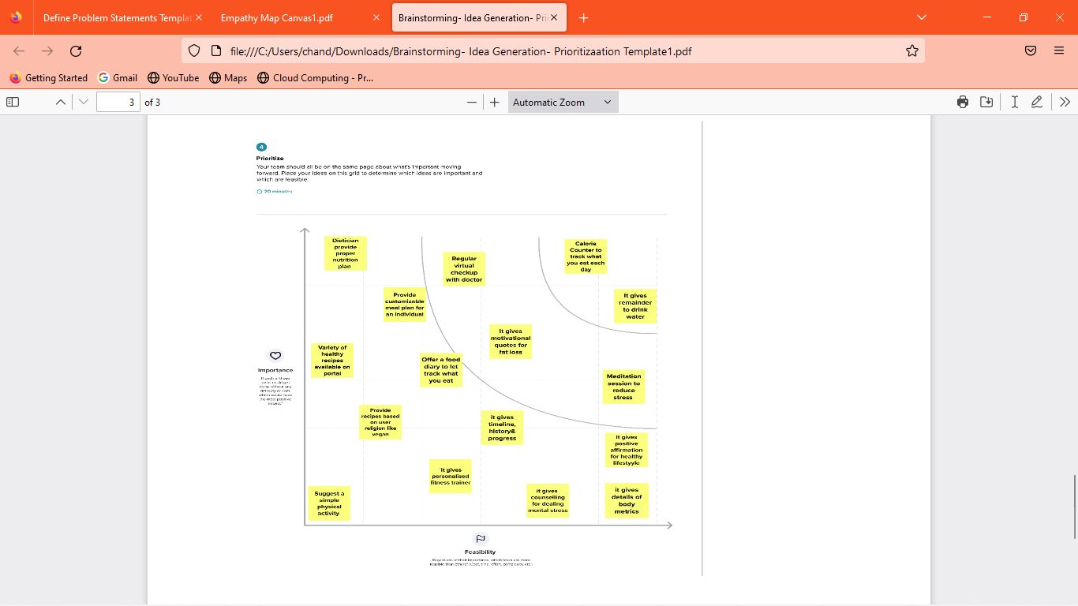

# PROPOSED SOLUTION

PROBLEM STATEMENT (PROBLEM TO BE SOLVED)

Due to the ignorance of healthy food habits, obesity rates are increasing at an alarming speed, and this is reflective of the risks to people’s health. People need to control their daily calorie intake by eating healthier foods, which is the most basic method to avoid obesity. However, although food packaging comes with nutrition (and calorie) labels, it’s still not very convenient for people to refer to App-based nutrient dashboard systems which can analyze real-time images of a meal and analyze it for nutritional content which can be very handy and improves the dietary habits, and therefore, helps in maintaining a healthy lifestyle.

IDEA / SOLUTION DESCRIPTION

This project aims at building a web App that automatically estimates food attributes such as ingredients and nutritional value by classifying the input image of food. Our method employs Clarifai's AI-Driven Food Detection Model for accurate food identification and Food API's to give the nutritional value of the identified food

NOVELTY / UNIQUENESS

In this project, User interacts with the Web App to Load an image.The image is passed to the server application, which uses Clarifai's AI-Driven Food Detection Model Service to analyze the images and Nutrition API to provide nutritional information about the analyzed Image.Nutritional information of the analyzed image is returned to the app for display.

SOCIAL IMPACT / CUSTOMER SATISFACTION

Due to the ignorance of healthy food habits, obesity rates are increasing at an alarming speed, and this is reflective of the risks to people’s health. People need to control their daily calorie intake by eating healthier foods, which is the most basic method to avoid obesity. However, although food packaging comes with nutrition (and calorie) labels, it’s still not very convenient for people to refer to App-based nutrient dashboard systems which can analyze real-time images of a meal and analyze it for nutritional content which can be very handy and improves the dietary habits, and therefore, helps in maintaining a healthy life.

BUSINESS MODEL (REVENUE MODEL) 9

A revenue model means understanding how a startup can make money. Our

major revenue sources consist of sales, government funds, and public donations.

The introduction of novel ideas increases revenue streams, such as special dietary needs, Clarifai's AI-Driven Food Detection Model, Food API's to give the nutritional value etc..

SCALABILITY OF THE SOLUTION

Making use of cloud-native techniques is one way to automatically estimates food attributes such as ingredients and nutritional value by classifying the input image of food. IBM Cloud, for instance, is one of the cloud-based AI scalability options. Run and manage AI models, as well as optimise decisions at scale across any cloud, with the aid of IBM Cloud Build. The benefit of using the cloud to scale solutions is that we can install our AI programme there. the specific cloud environment that best supports our business needs. We can take advantage of built-in security capabilities and AI model monitoring. we can drive better business outcomes by optimizing our decisions and also make our solution scalable using cloud.

## PROBLEM SOLUTION FIT

The Problem solution aims at building a web App that automaticall estimates food attributes such as ingredients and nutritional value by classifying the input image of food. Our method employs Clarifai's AI-Driven Food Detection Model for accurate food identification and Food API's to give the nutritional value of the identified food..

## PURPOSE:

* Solve complex problems in a way that fits the state of your customers.
* Succeed faster and increase your solution adoption by tapping into existing mediums and

channels of behavior.

* Sharpen your communication and marketing strategy with the right triggers and messaging.
* Increase touch-points with your company by finding the right problem- behavior fit and

building trust by solving frequent annoyances, or urgent or costly problems.

* Understand the existing situation in order to improve it for your target group.

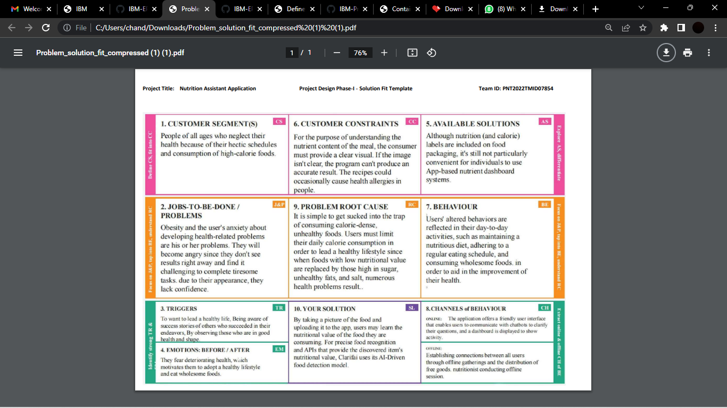

## REQUIREMENT ANALYSIS FUNCTIONAL REQUIREMENTS

* + Users have to register their personal details.
  + User has to upload the image of the food
  + The nutritional values of the food will be dispalyed

## NON-FUNCTIONAL REQUIREMENTS

PERFORMANCE

Performance is measured in terms of the output provided by the application. Requirement specification plays an important part in the analysis of a system. Only when the requirement specifications are properly given, it is possible to design an application, which will fit into the required environment. The load for the user interface screens shall take no longer than 2 seconds. The login information shall be verified within 5 seconds. Queries shall return results within 5 seconds.

SAFETY AND SECURITY REQUIREMENTS

* + User Identification:

The system requires the user to identify himself/herself User

* + Login ID:

Any user who uses the system shall have a Login.

* + Modification:

Any modification (insert, delete (or) update) for the Database shall be synchronized and done only by the admin in the ward.

* + Admin Rights:

Admin shall be able to view and modify the information.

## PROJECT DESIGN

**DATA FLOW DIAGRAMS**

A Data Flow Diagram (DFD) is a traditional visual representation of the information flows within a system. A neat and clear DFD can depict the right amount of the system requirement graphically. It shows how data enters and leaves the system, what changes the information, and where data is stored.

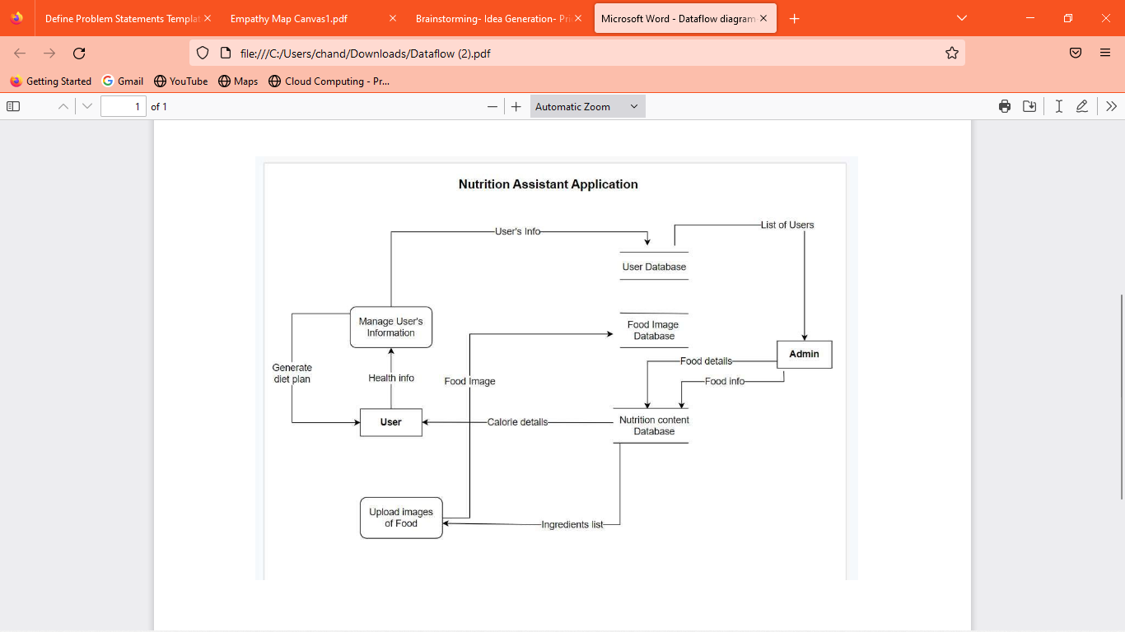

## SOLUTION AND TECHNICAL ARCHITECTURE

PROJECT DESCRIPTION:

Due to the ignorance of healthy food habits, obesity rates are increasing at an alarming speed, and this is reflective of the risks to people’s health. People need to control their daily calorie intake by eating healthier foods, which is the most basic method to avoid obesity. However, although food packaging comes with nutrition (and calorie) labels, it’s still not very convenient for people to refer to App-based nutrient dashboard systems which can analyze real-time images of a meal and analyze it for nutritional content which can be very handy and improves the dietary habits, and therefore, helps in maintaining a healthy lifestyle.This project aims at building a web App that automatically estimates food attributes such as ingredients and nutritional value by classifying the input image of food. Our method employs Clarifai's AI-Driven Food Detection Model for accurate food identification and Food API's to give the nutritional value of the identified food.

## TECHNICAL ARCHITECTURE

## 

## 

**SOLUTION**

* + User interacts with the Web App to Load an image.
  + The image is passed to the server application, which uses Clarifai's AI- Driven Food Detection.
  + Model Service to analyze the images and Nutrition API to provide nutritional information about the analyzed Image.
  + Nutritional information of the analyzed image is returned to the app for display.

## PROCEDURE

1. IMPLEMENTING WEB APPLICATION
   * Registration (Push the registration data into the database)
   * Login (Fetch the data upon login)
   * Upload the food image and get the prediction
   * Get Calories from the food items
   * Add food data to the database
2. CREATE UI TO INTERACT WITH THE APPLICATION
   * Registration Page
   * Login Page 14
   * Upload Image page
   * Prediction results page for food items
   * View history of items
3. CREATE IBM DB2 AND CONNECT WITH PYTHON
   * Create the IBM Db2 service in the IBM cloud and connect the python code with DB.
4. INTEGRATE NUTRITION API
   * Integrate the Nutrition API to the flask with API call.

## APPROACH:

Nutrition assistant application is designed to compress the broad knowledge that exists in nutrition, Many people will be attracted to Nutrition because they have special dietary needs. Some had food allergies or sensitivities; others were vegan or vegetarian; many were pregnant. A number of pregnant women reached out to us asking for more detailed information and guidance.

KUBERNETES CLUSTERS - Kubernetes clusters allow containers to run across multiple machines and cloud based application.

IBM DB2- Used for Backup & recovery. Comprehensive data resilience for physical and virtual servers.Cloud hosting. Dedicated, virtual private, and bare metal server options

CONTAINER REGISTRY - Container Registry is a single place for your team to manage Docker images, perform vulnerability analysis, and decide who can access what with fine-grained access control

NUTRITION API **-** A nutrition API acts as a container for information from thousands of products. When an application sends a GET request to the API, it returns the nutrition information about a given product.

## RESULT:

Despite processing, we do not believe that our outcomes are flawless. There is always opportunity for improvement in your procedure because cloud computing is a topic that is constantly developing. Additionally, there will always be new approaches that offer better results for the same problems. It has been done, the application. Clarifai's AI-Driven Food Detection Model Service, Nutrition API.

15

## USER STORIES

|  |  |  |  |  |  |  |
| --- | --- | --- | --- | --- | --- | --- |
| **User Type** | **Functional Requireme nt (Epic)** | **User Story Number** | **User Story / Task** | **Acceptance criteria** | **Priority** | **Release** |
| Customer | Registration | USN-1 | As a user, I can register for the application by  entering my  Name, Age, Gender, E-mail, password, and  confirming my password. | I can access my account / dashboard | High | Sprint-1 |
|  |  | USN-2 | As a user, I will receive confirmation email once I have registered for the application. | I can receive confirmation email & click confirm. | High | Sprint-1 |
|  |  | USN-3 | As a user, I have to enter my height, weight and daily activity details. | I can update these information on Dashboard. | Low | Sprint-1 |
|  | Login | USN-4 | As a user, I can login to the  application by entering E-mail and password. | I can access my account/ dashboard. | Low | Sprint-1 |
|  | Dashboard | USN-5 | As a user, I can upload or capture live image of the meal | I can get the nutritional value of that particular meal. | High | Sprint-1  16 |

|  |  |  |  |  |  |  |
| --- | --- | --- | --- | --- | --- | --- |
|  |  |  |  |  |  |  |
|  |  | USN-6 | As a user,I can get the nutritional value of that particular meal. | I can get the nutritional value of that particular meal. | High | Sprint-2 |
| Administrator | Maintain the Application | USN-7 | Maintaining details for users. | I can access database | High | Sprint-3 |
|  |  | USN-8 | As a user, I want to be able to upload a picture of the recipe | I can upload the recipe’s picture | High | Sprint-3 |
|  |  | USN-9 | As a user, I want to be able to view the nutrition profile of the meal in my saved recipes | I can view my profile Account / save recipes to my profile | Low | Sprint-3 |
|  |  | USN-10 | As a user, when i click on the nutrition profile i want it easily readable with most relevant information at the top. | I want to study the profile with readable information | Medium | Sprint-4 |
|  |  | USN-11 | As a user, when i view my weekly totals I want averages and other pertinant information | I can manage the average of information in weekly basis | High | Sprint-1 |

**PROJECT PLANNING & SCHEDULING**

## SPRINT PLANNING & ESTIMATION

**PRODUCT BACKLOG, SPRINT SCHEDULE, AND ESTIMATION**

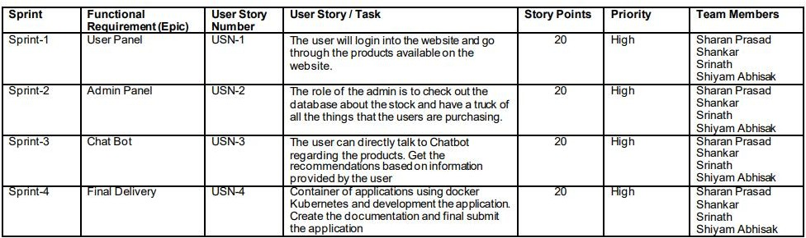

## PROJECT TRACKER, VELOCITY & BURNDOWN CHART

|  |  |  |  |  |  |  |
| --- | --- | --- | --- | --- | --- | --- |
| **Sprint** | **Total Story points** | **Duration** | **Sprint Start Date** | **Sprint End Date(Planne d)** | **Story Points Completed (as on planned end date)** | **Sprint Release Date(actual)** |
| Sprint-1 | 20 | 6 Days | 24 Oct 2022 | 29 Oct 2022 | 20 | 29 Oct 2022 |
| Sprint-2 | 20 | 6 Days | 31 Oct 2022 | 05 Nov 2022 | 20 | 05 Nov 2022 |
| Sprint-3 | 20 | 6 Days | 07 Nov 2022 | 12 Nov 2022 | 20 | 12 Nov 2022 |
| Sprint-4 | 20 | 6 Days | 14 Nov 2022 | 19 Nov 2022 | 20 | 19 Nov 2022 |

**VELOCITY:**

Imagine we have a 10-day sprint duration, and the velocity of the team 20(points per sprint).Let’s calculate the team’s average velocity (AV) per iteration unit.

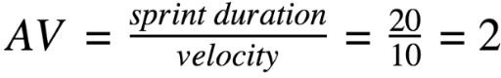

## SPRINT DELIVERY SCHEDULE REPORT FROM JIRA

**CODING & SOLUTION FEATURE 1 : LOGIN**

## Algorithm :

1. Enter the credentials and hit enter (email and password).
2. If already logged in user is taken to home page
3. Else , check for validity of credentials entered using query to cloudant db.
4. If wrong credentials entered , notification displayed to user and user stays in login page.
5. On correct credentials , user is taken to home page.

## Login checker :

div class="container">

<div class="row">

<div class="col-lg-12">

<h1>Log In</h1>

<p>You don't have a password? Then please <a

class="white" href="sign-up.html">Sign Up</a></p>

<!-- Sign Up Form -->

<div class="form-container">

<form id="logInForm" data toggle="validator" data-focus="false">

<div class="form-group">

<input type="email" class="form control-input" id="lemail" required>

<label class="label-control" for="lemail">Email</label>

<div class="help-block with

errors"></div>

</div> 20

23

<div class="form-group">

<input type="text" class="form control-input" id="lpassword" required>

<label class="label-control" for="lpassword">Password</label>

<div class="help-block with

errors"></div>

</div>

<div class="form-group">

<button type="submit" class="form control-submit-button">LOG IN</button>

</div>

<div class="form-message">

<div id="lmsgSubmit" class="h3 text-center hidden"></div>

</div>

</form>

</div> <!-- end of form container -->

## FEATURE 2 : SIGNUP

**Algorithm :**

1. Enter the signup form fields (name , email , password , re-enter password , date of birth ) and hit enter.
2. All credentials are validated at client side.
3. Email is checked if already registered or not in the database.
4. If already registered , notification displayed. Or else, the user is taken to the successful signup page.

## Query to check if email is registered or not :

<div class="form container">

<form id="logInForm" data-toggle="validator" data- focus="false">

<div class="form-group">

<input type="email" class="form-control input" id="lemail" required>

<label class="label-control"

21

for="lemail">Email</label>

24

<div class="help-block with errors"></div>

</div>

<div class="form-group">

<input type="text" class="form-control input" id="lpassword" required>

<label class="label-control" for="lpassword">Password</label>

<div class="help-block with errors"></div>

</div>

<div class="form-group">

<button type="submit" class="form control- submit-button">LOG IN</button>

</div>

<div class="form-message">

<div id="lmsgSubmit" class="h3 text center hidden"></div>

</div>

</form>

</div> <!-- end of form container -->

## FEATURE 3 : HOME

**Algorithm :**

* 1. If the user is logged out , he/she is taken to the login page.
  2. Home page buttons are displayed (Live tracker , Recent emergency notifications , Location history , Change password , Logout)
  3. If buttons are clicked , the user is taken to the requested page.

## TESTING

**TEST CASES**

1. Login button click with wrong credentials entered.
2. Signup with already registered mail ID.
3. Signup with wrong form data entered.
4. Entering home page with logged out session.
5. Clicking home page buttons with logged out session.
6. Invalid data entered in change password page and requested for change in password.

## USER ACCEPTANCE TESTING

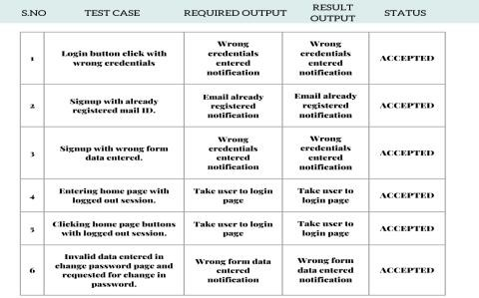

**RESULTS PERFORMANCE METRICS**

* + 1. Planned value : Rs.4000
    2. Actual value : Rs.1300
    3. Hours worked : 50 hours
    4. Stick to Timelines : 100%
    5. Stay within budget : 100%
    6. Consistency of the product : 75%
    7. Efficiency of the product : 80%
    8. Quality of the product : 80%

24

27

## ADVANTAGES AND

**DISADVANTAGES**

## ADVANTAGES :

1. Low cost.
2. Simple UI.
3. Faster response due to single page web page.
4. Capability of adding many features with ease and less cost.

## DISADVANTAGES :

1. Lack of efficiency . Efficiency of the product needs to be improved.
2. Consistency of the product is not 100%.
3. Not a compact sized product. Size needs to be decreased.

## CONCLUSION

Dietary tracking is an essential task in chronic disease management and intervention. Food photo taking and image recognition significantly reduce the burden of food entering on personal mobile devices. In this work, we have developed a dietary tracking system that applies the deep-based image recognition to accurately and efficiently log food and nutrition intake. Through real user food photo testing and user study, we found that laboratory models form the foundation of the solution but miss out some of the key challenges. The diversity of real food photos is higher than the lab trained model. An ingredient based recognition is a promising way of tracking the free style and homemade food recognition problems in which training data is sparse and not representative. Moreover, the proposed photo based portion selection method is shown to be more accurate and engages the users better than the existing 25 methods.

## FUTURE SCOPE

In future we'll be adding more features which will benefit the users. The ui/ux of the web application will be improved. Scaling the project for more use cases and customers. Implementing distributed computing for efficient processing.Making encryption standard for cloud storage.

SOURCE CODE LINK:

<https://github.com/IBM-EPBL/IBM-Project-19922-1659709070>

DEMO VIDEO LINK:

[https://drive.google.com/file/d/1D8Y4QQ_C4lRX_WIHZnqPQKrFMFE](https://drive.google.com/file/d/1D8Y4QQ_C4lRX_WIHZnqPQKrFMFEGfsEm/view?usp=drivesdk) GfsEm/view?usp=drivesdk

26